Dear Alley Of Kids,

On Friday, October 26th, Big Brothers Big Sisters of Central Oregon will host its 21st Annual Comedy for Kids’ Sake, at the Tower Theater in Downtown Bend. This “Red Carpet Evening” of laughter and entertainment is a benefit for Big Brothers Big Sisters of Central Oregon.

The Tower doors will open at 6:00pm for the Sponsor VIP Reception that will include complimentary appetizers, drinks and a pre-bidding opportunity for all silent auction packages. The doors will open to the general public at 7:00pm.

Two hysterical comedians will be featured for the night and are bound to send you home laughing! The evening will also provide both a silent and live auction. Last year’s auction included a fishing trip to Patagonia, trips to Bali and many more!

All proceeds from Comedy for Kids’ Sake Benefit 2018 will go towards matching 60 new children in our community with caring adult mentors. Think back to when you were little. Who was that person who put a smile on your face? Help us to make a BIG difference in the life of a child by becoming a sponsor of this year’s signature event.

We encourage you to purchase a sponsorship package as soon as possible as space is limited. The enclosed information sheet lists the various sponsorship opportunities available and benefits to the sponsors.

Thank you for your consideration and we look forward to hearing from you soon.

Sincerely,

Elysia Kiyija

Elysia Kiyija
Big Brothers Big Sisters of Central Oregon
541.312.6047
Elysia@bbbsco.org

2018 COMEDY FOR KIDS’ SAKE SPONSORSHIP OPPORTUNITIES

Presenting Sponsor ~ $5,000 (Limited to one)

- Business recognized as the Presenting Sponsor on all marketing & media advertisements
- 20 Front Row tickets & complimentary beer & wine wristbands to Comedy for Kid’s Sake
- VIP Reception access
- 1 Full Page Color Ad in event program
- Presenting level placement of signage at event
- Logo on 420 event tickets and programs handed out at event
- Verbal recognition of sponsor at event
- Presenting Sponsor placement in the thank you advertisement printed in The Source

Platinum Sponsor ~ $3,500

- Business recognized as the Platinum Sponsor on all marketing & media advertisements
- 10 Platinum Level seating tickets and complimentary beer & wine wristbands to Comedy for Kid’s Sake
- VIP Reception Access
- Half Page Color Ad in event program
- Platinum level placement of signage at event and in program
- Verbal recognition of sponsor at event
- Platinum sponsor placement in the thank you advertisement printed in The Source

Gold Sponsor ~ $2,500

- Business recognized as the Gold Sponsor on all marketing & media advertisements
- 8 Gold Level Seating tickets and 16 drink tickets to Comedy for Kid’s Sake
- VIP Reception access
- 1/4 Page Color Ad in event program
- Gold level placement of signage at event
- Verbal recognition of sponsor at event
- Gold sponsor placement in the thank you advertisement printed in The Source

Silver Sponsor ~ $1,500

- Business recognized as the Silver Sponsor on all marketing & media advertisements
- 6 Silver Level Seating tickets and 12 drink tickets to Comedy for Kid’s Sake
- VIP Reception access
- Verbal recognition of sponsor at event
- Silver sponsor placement in the thank you advertisement printed in The Source

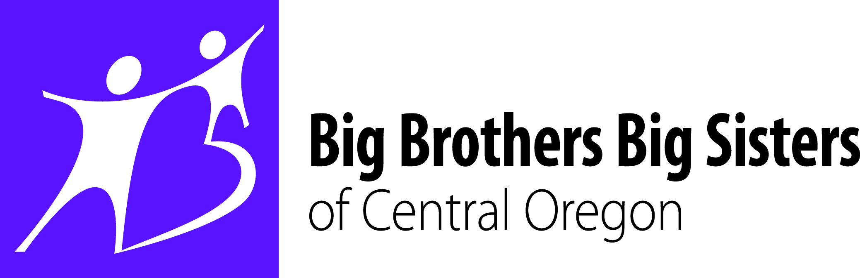

2018 COMEDY FOR KIDS’ SAKE SPONSORSHIP REPLY FORM

NAME: _____________________________________________________

COMPANY: _________________________________________________

ADDRESS: _________________________________________________

CITY: _____________ STATE: ______ ZIP: ______________________

PHONE: ___________________ E-MAIL: ______________________________

□ Presenting $5000 □ Platinum $3,500
□ Gold $2,500 □ Silver $1,500

____ Enclosed is my check payable to Big Brothers Big Sisters of Central Oregon

____ Please Bill Me

____ Charge My Credit Card (we will contact you to complete transaction)

Signature: ______________________________________

□ I would like to donate to BBBS monthly to help support mentoring.
□ $10
□ $25
□ Other $________

Big Brothers Big Sisters of Central Oregon
Attn: Bridget Albert
2125 NE Daggett Lane
Bend, OR 97701

